**Seminar on Personality Development conducted on 29/06/2022**

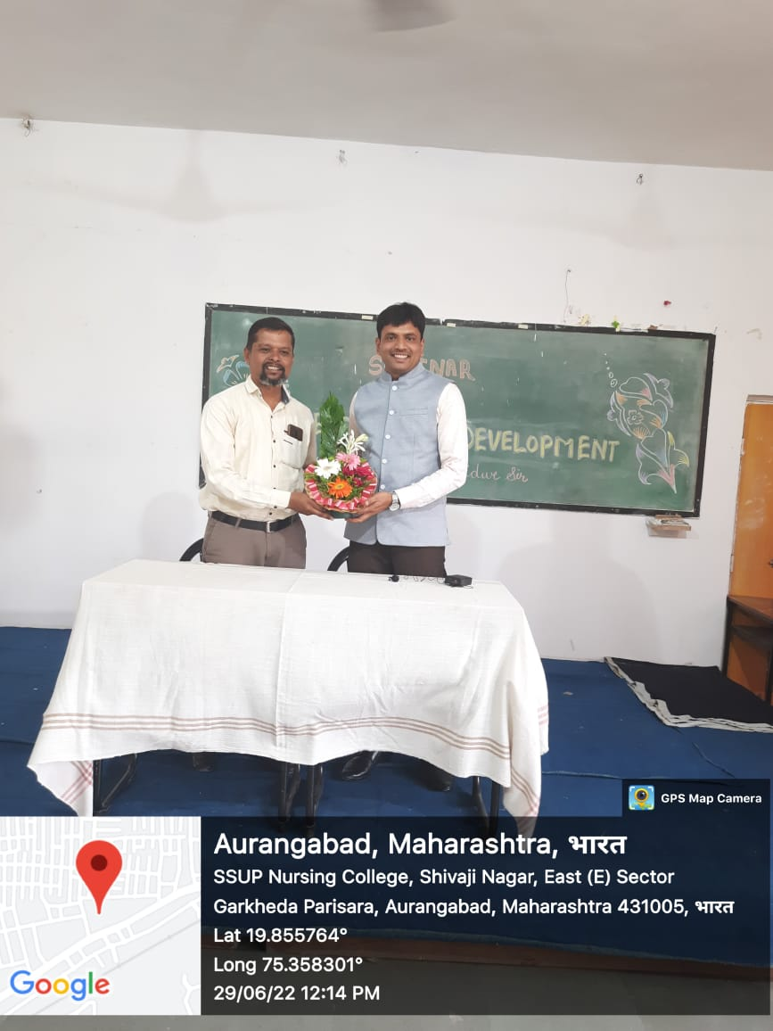 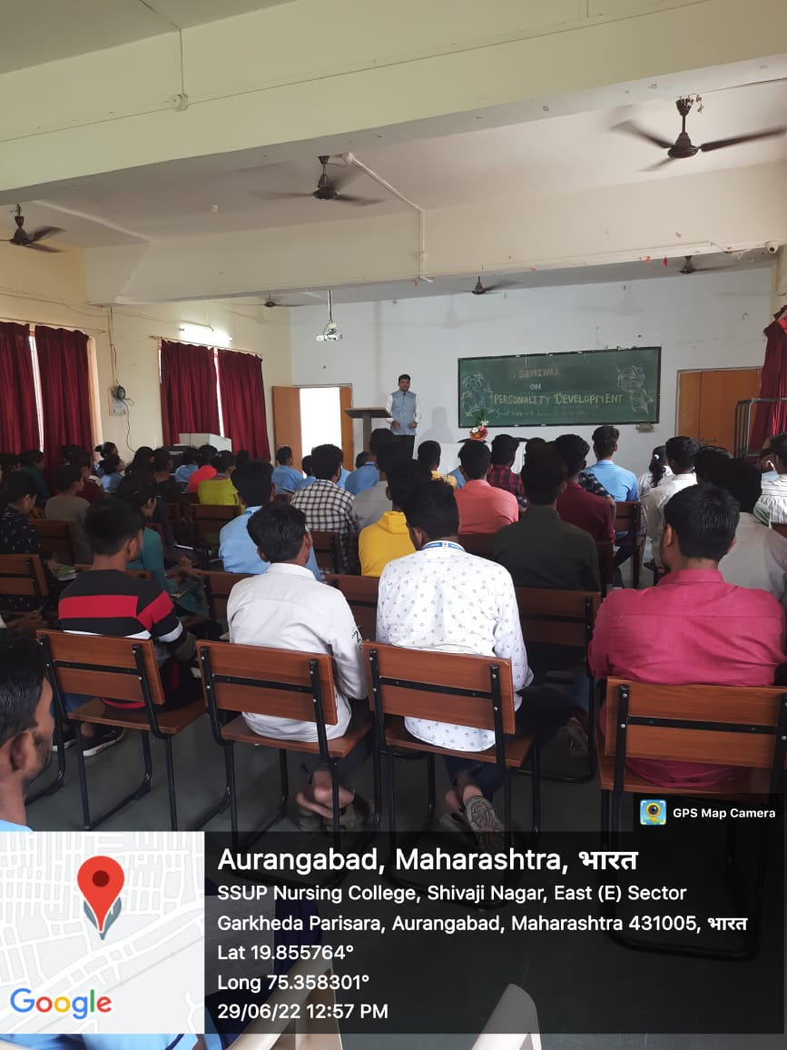

**Our Principal Welcoming to Resourse person Pro.Raman Bidwe Participants**